Pixy 2: We are using the pixy2 camera for its multiple functionalities. We are mainly using it for its object and colour detection of the pixy. The pixy 2 will detect the colour, and size and distance of the object in front and which object is in front. It will help us make a right turn from the red block and left turn from the green block in front. We do all of this by connecting the pixy to the Arduino nano.

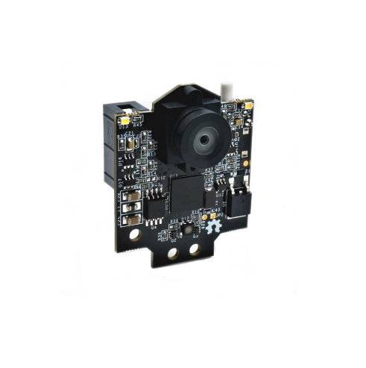

Arduino: The Arduino is used by us for its multiple functionality that it offers. We are connecting the motor and the pixy to the Arduino so that we can upload the code in the Arduino microcontroller and with make the motor and the pixy function. The Arduino is the heart and soul for of our bot and it cannot function without it. 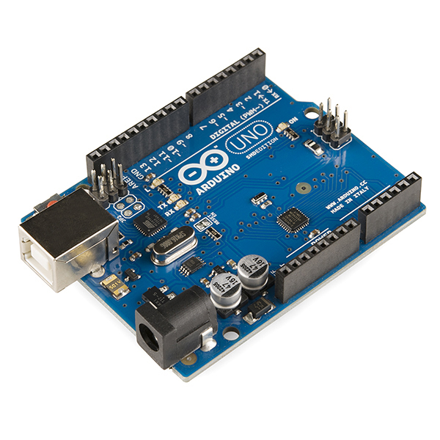

N20 motor (600 rpm): We are using the n20 motor with 600RPM and 12V rating as it is a highly efficient ,powerful and reliable motor. After mulitiple test this motor presented to proide us with enough torque to move the robot and good engouh speed to complete the round in less than a minute. the reules it is given that we can only use one motor to drive the bot therefore we are using this motor as it is one of the only few motors that offers a high rpm and the mechanical structre is a lego differential gear which is able to divde the power and speed equally beween the two wheels.

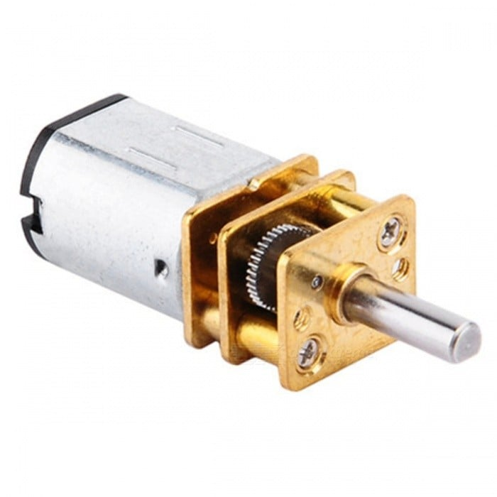

Ultrasonic sensor: We are using the ultrasonic sensor as it is highly reliable efficient and provides a perfect price to performance ratio. We are using it to detect the walls around the bot when it runs. So that it doesn’t run into the walls and yet remains close to the inside to walls to take the shortest distance hence reducing the lap time.

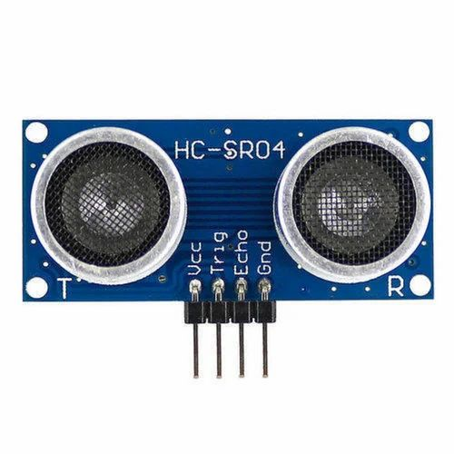

Tb6612fng: This is a motor driver quite small in size but with major functionality. We connect this to the Arduino on one end to get the input and the motor on the other end for the output. We get the code inputted from the Arduino and the motor driver conveys it to the motor which controls the wheels and makes the bot as a whole move and complete our laps.

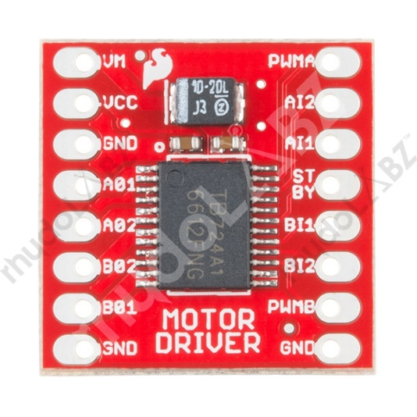

3D printed modules: firstly we have printed a d shaft and an attachment to the axle which connects to the wheels and is connect to the motor on the other side which gives the power to the wheels to rotate

* 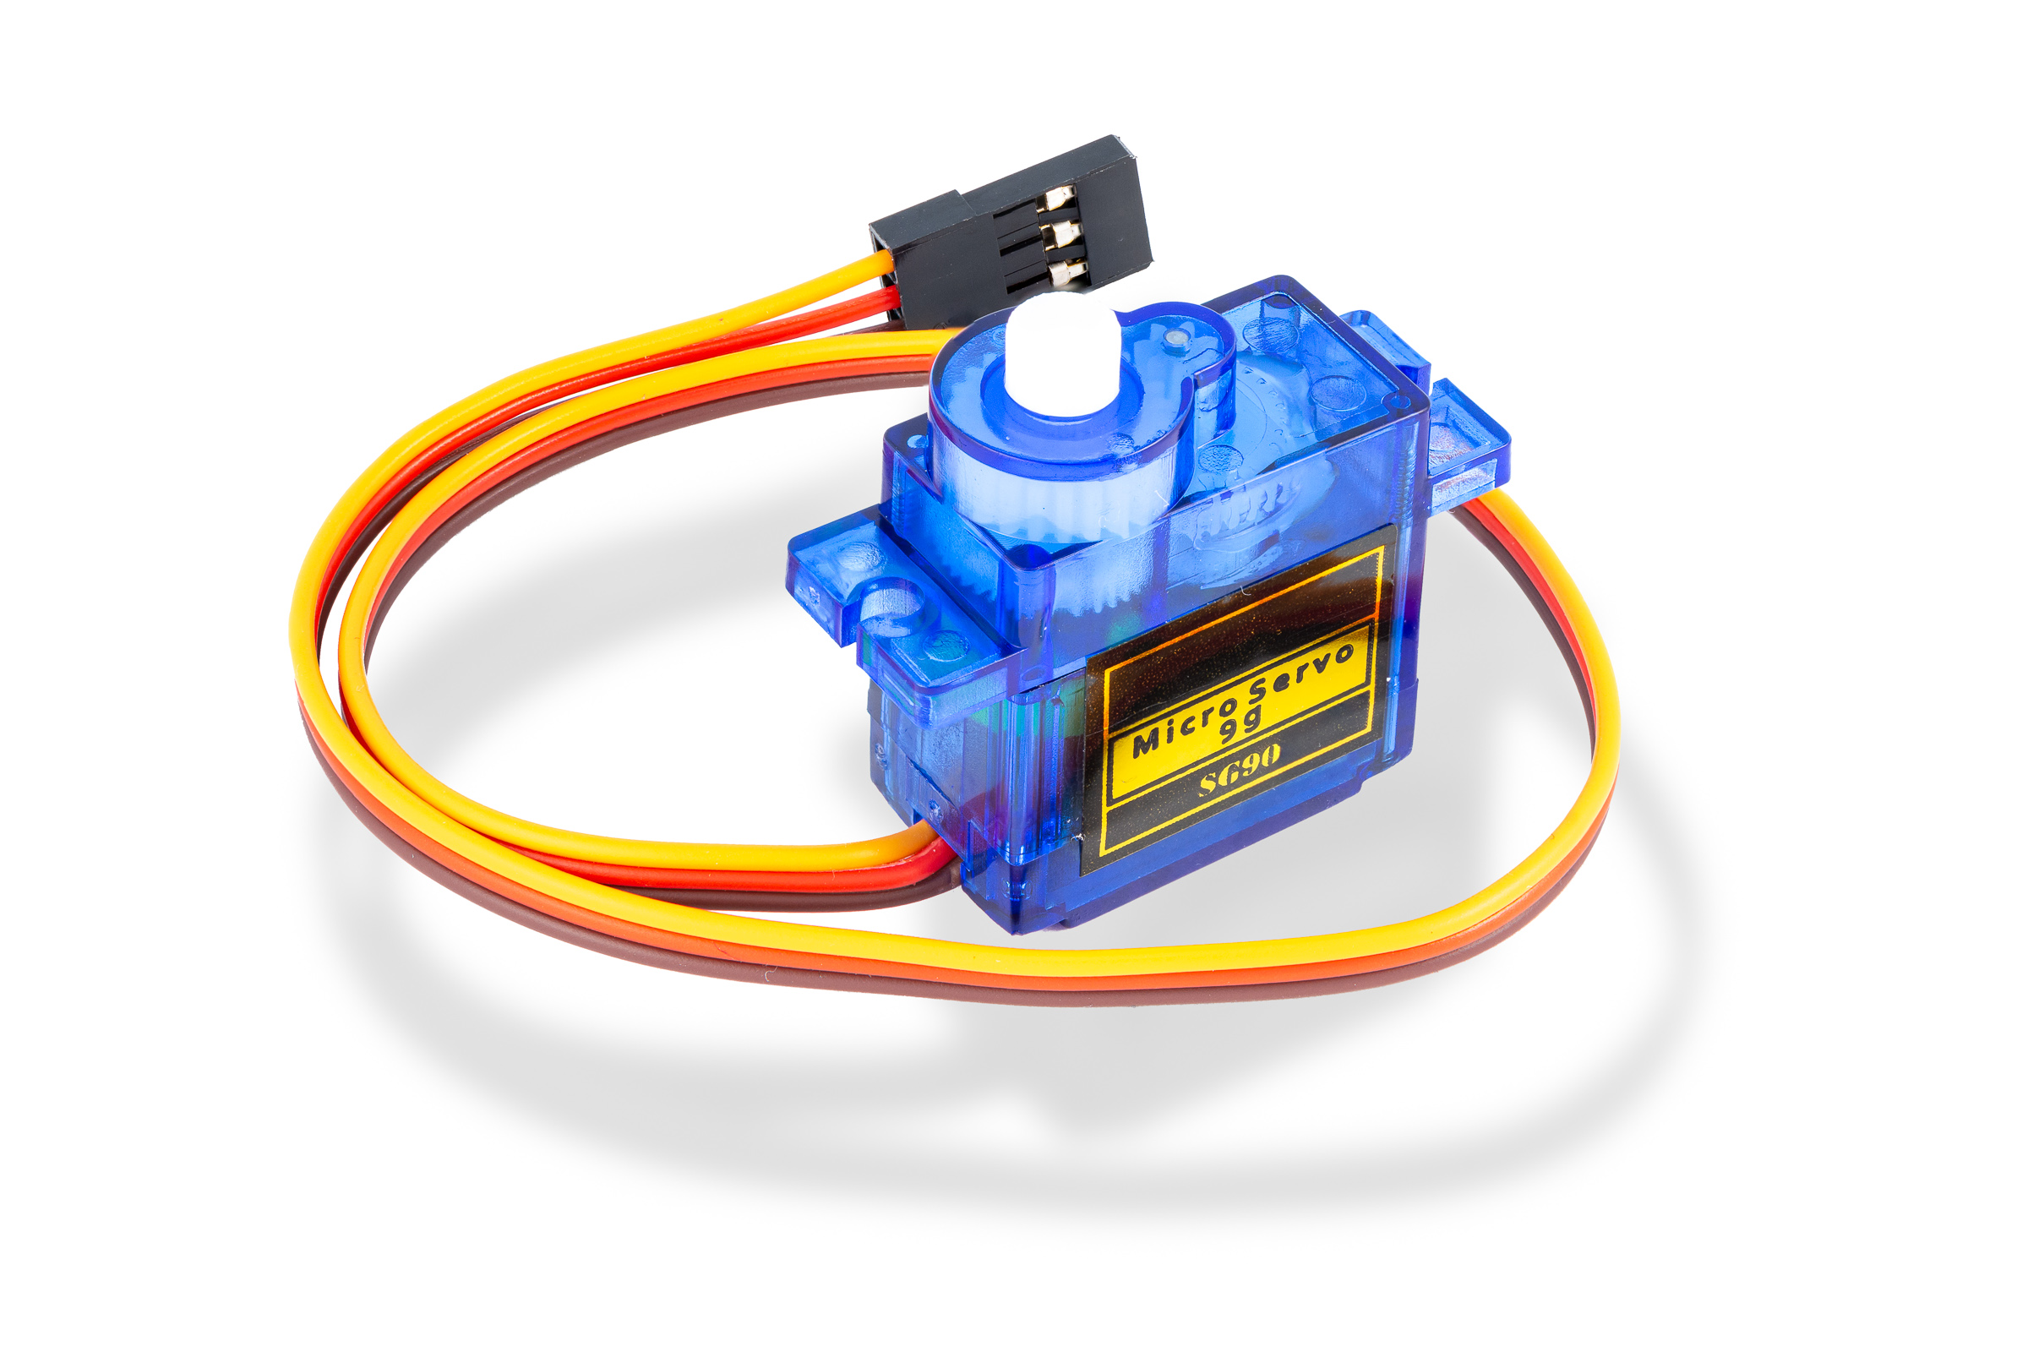

Secondly we made a steering mechanism using 3D printing with the servo in the middle , wheels with the bearings in the side with the ball bearings. This will be our front structure to make the bot turn.

We are using 3D printing to create a cover for our pixy camera too.

LEGO: Lego makes the main base of the car. We are using lego parts to makes our chassis, we are using lego wheels, lego axles and other lego parts as the main body of our bot.

12V Lipo battery: We are using a 12V Lipo battery as a power supply as the n20 motor operates on 12V exactly.

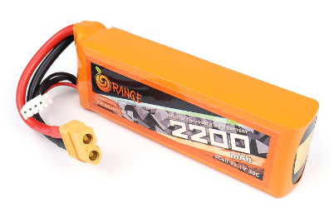

IMU sensor: We are using the BNO55 sensor to act as a gyro and align the bot in a straight line whenever it deviates from it.

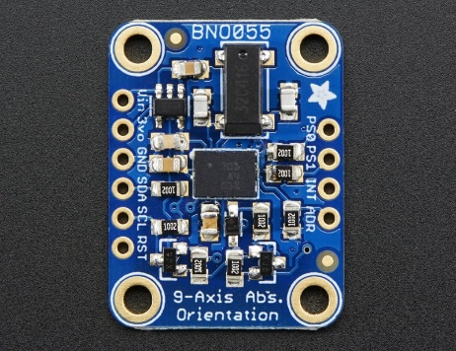

Servo motor: We are using the mg90 servo for the steering of the robot . We chose this over the sg90 as it has metal gears giving us better turns and more accuracy and prevents the risk of gears slipping.

